AWS WEEKLY TEST -01

Introduction to Amazon Web Service(AWS)
(AWS) is a cloud computing platform provided by Amazon. It offers on-demand IT services like servers, storage, databases, networking, and more — all delivered over the internet.
Instead of buying physical servers, companies can rent resources from AWS and pay only for what they use.
꾆 Common AWS Services:
- EC2 (Elastic Compute Cloud) – Virtual servers
- S3 (Simple Storage Service) – Cloud storage
- RDS (Relational Database Service) – Managed databases
- Lambda – Serverless computing
- VPC (Virtual Private Cloud) – Networking service

膆 Advantages of AWS 膆膊 Cost Effective
- Pay-as-you-go pricing model
- No need to buy physical hardware 膋膆 Scalability
- Easily increase or decrease resources
- Auto-scaling available 膆膌 Global Infrastructure
- Data centers available worldwide 膆膍 High Availability
- Services are reliable and fault-tolerant 膏膎 Security
- Strong security features
- IAM (Identity and Access Management) for access control 膆膐 Large Service Ecosystem
- 200+ cloud services available

 Disadvantages of AWS 膆膊 Complex Pricing
- Pricing structure can be confusing 膋膆 Learning Curve
- Many services → difficult for beginners 膆膌 Dependency on Internet
- Requires stable internet connection 膆膍 Vendor Lock-in
- Difficult to migrate applications to another cloud provider 膎膏 Technical Support Cost
- Premium support plans are expensive

AWS Regions
An AWS Region is a physical geographic location in the world where AWS has multiple data centers.
Each region contains multiple Availability Zones (AZs).
Example AWS Regions:
- Mumbai (ap-south-1)
- US East (N. Virginia)
- London (eu-west-2)
- Singapore (ap-southeast-1)

꾆 What is Availability Zone (AZ)?
An Availability Zone is one or more data centers inside a region.
Example:
If you choose the Mumbai Region, it may have:
- ap-south-1a
- ap-south-1b
- ap-south-1c
Each AZ is isolated but connected to others for high availability.

蚘蚓蚔蚕蚖蚗 Why Regions Are Important?
- Reduce latency (choose region close to users)
- Data compliance requirements
- Disaster recovery setup
- High availability architecture

膆껇껈 Simple Example
If your users are in India, choose: 踰踱踲踳 Mumbai Region (ap-south-1)
If your users are in USA, choose: 踰踱踲踳 US East (N. Virginia)
This improves performance and reduces delay.

If you want, I can also explain:
- Difference between Region and Availability Zone
- AWS Global Infrastructure diagram explanation
- AWS Free Tier details
- AWS interview questions & answers 뇤눎눐눑눒눏

AWS IAM Users and User Groups Creation.
What is IAM?
IAM lets you:
- Create Users (individual identities)
- Create Groups (collection of users)
- Assign Policies (permissions)
- Control access to AWS services securely

Step 1: specify the user details.
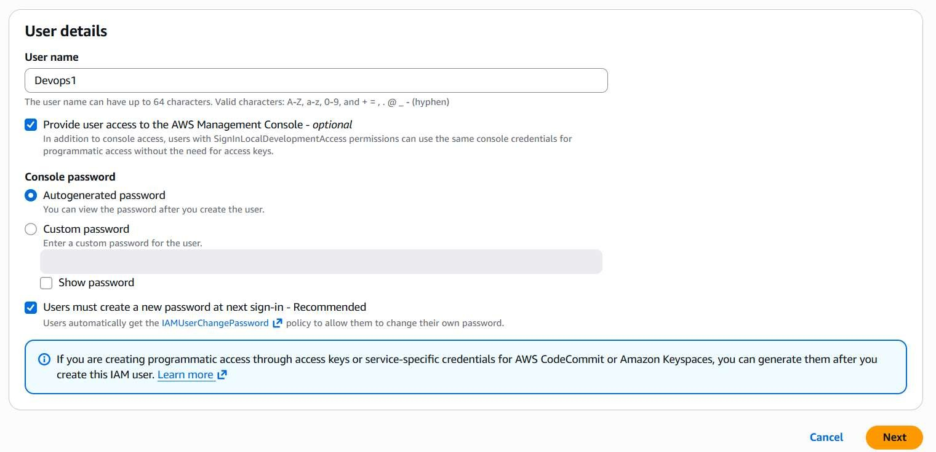
Step 2 : if you want you have to set permission.
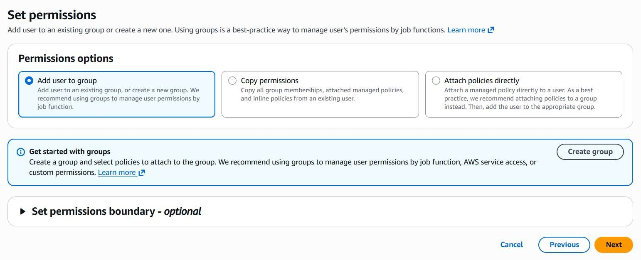
Step 3 : You can see the details of the permission and review the details.
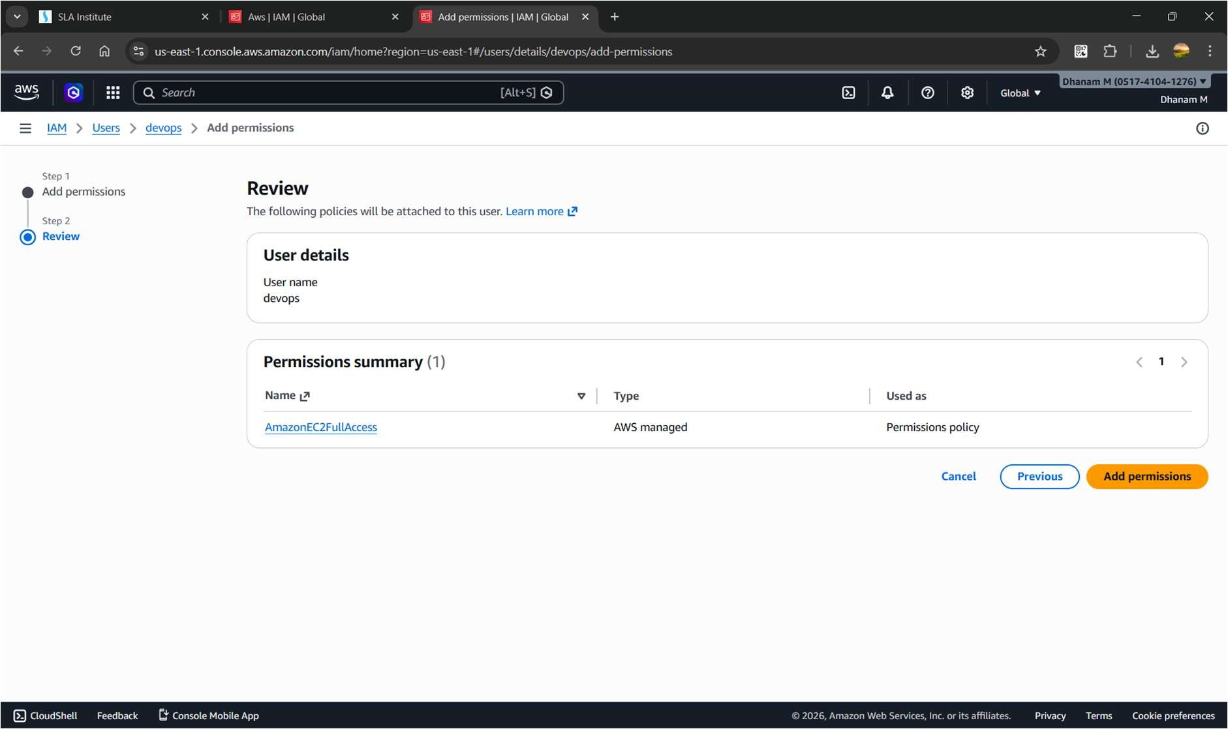
Step 4 : you have to download the csv file and you have to mail it to the personnel.
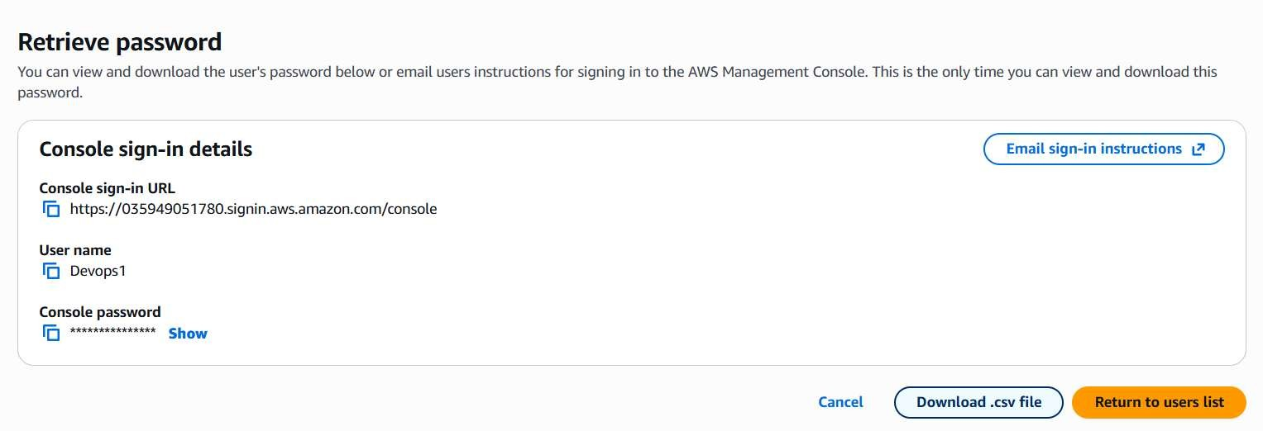
Step 5 : then we have to create an new password for the personnel.
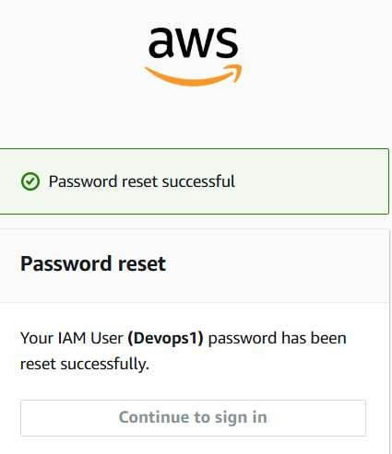
Creating an IAM Group
Groups are smart.
You don’t assign permissions to users individually — you assign to groups.
Example:
- Dev group → EC2 + S3 access
- Admin group → Full access
- ReadOnly group → View only

Step 1 : creating the user groups.
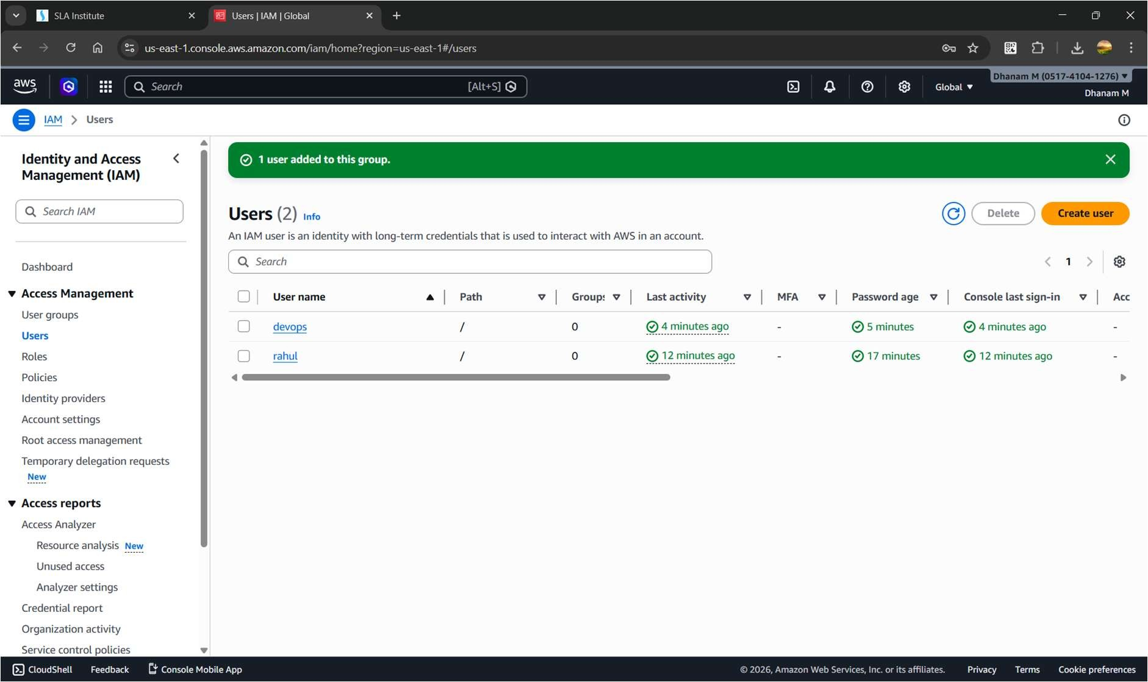
Step 2 : we can see the users in the group.
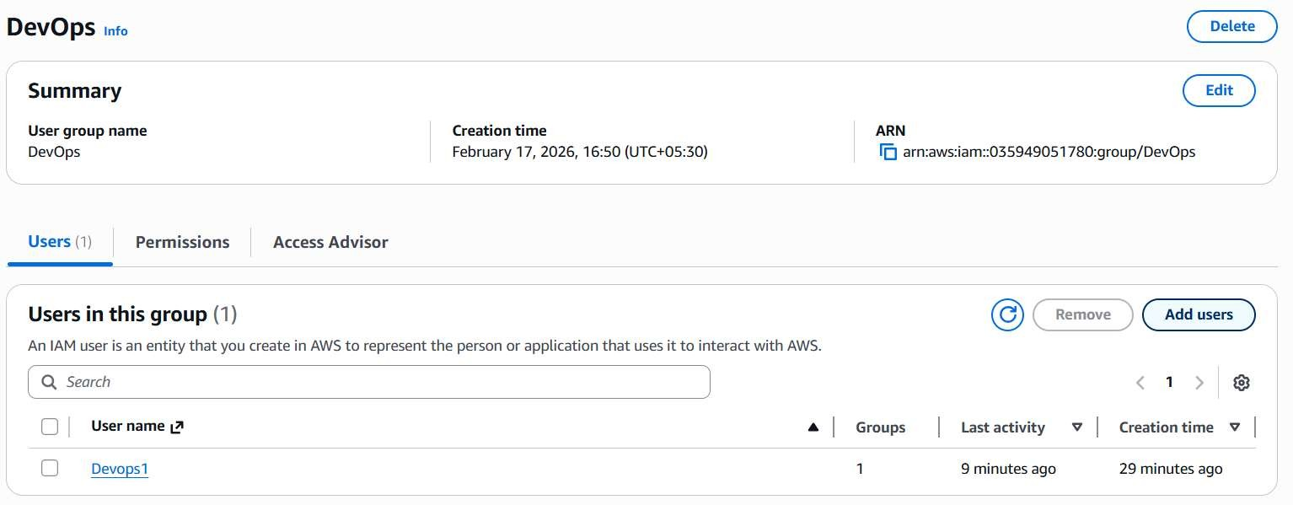
Add Users to Group
- Go to:
Users → Select user → Add to group → Select group → Save.
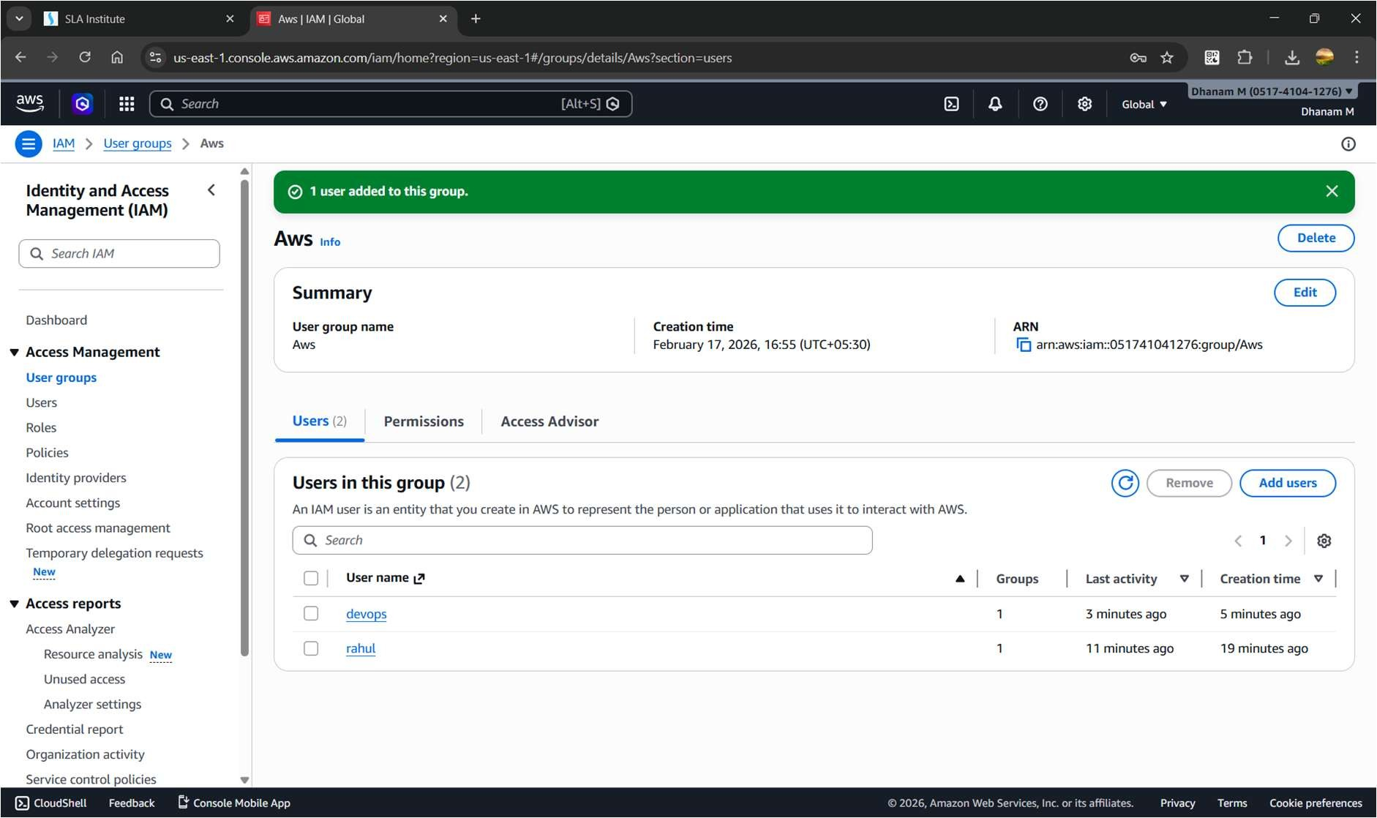
Giving permission to the user.
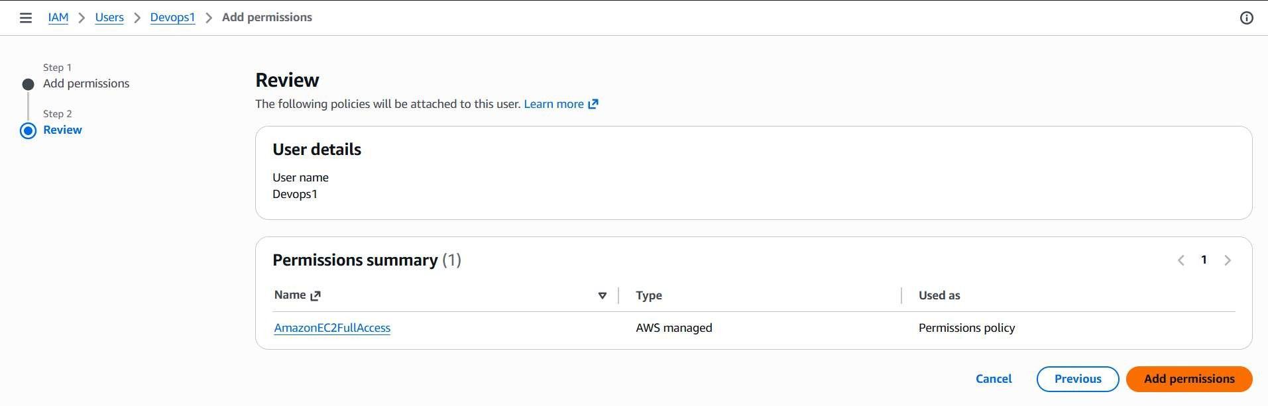
AWS IAM Roles and STS.
What is an IAM Role?
An IAM Role is a set of permissions that can be assumed temporarily.

Key point:

A role does NOT have permanent credentials. It gives temporary credentials via STS.

I have created an user and gave STS policy to that user.
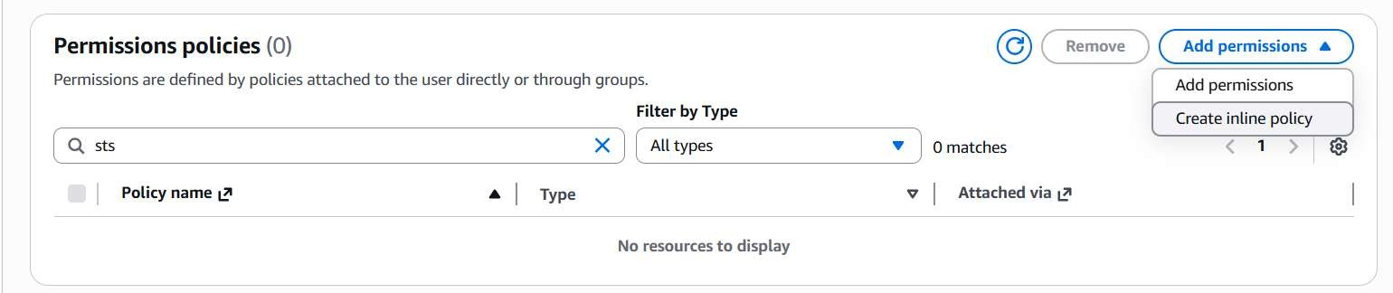
This is the page of the STS.
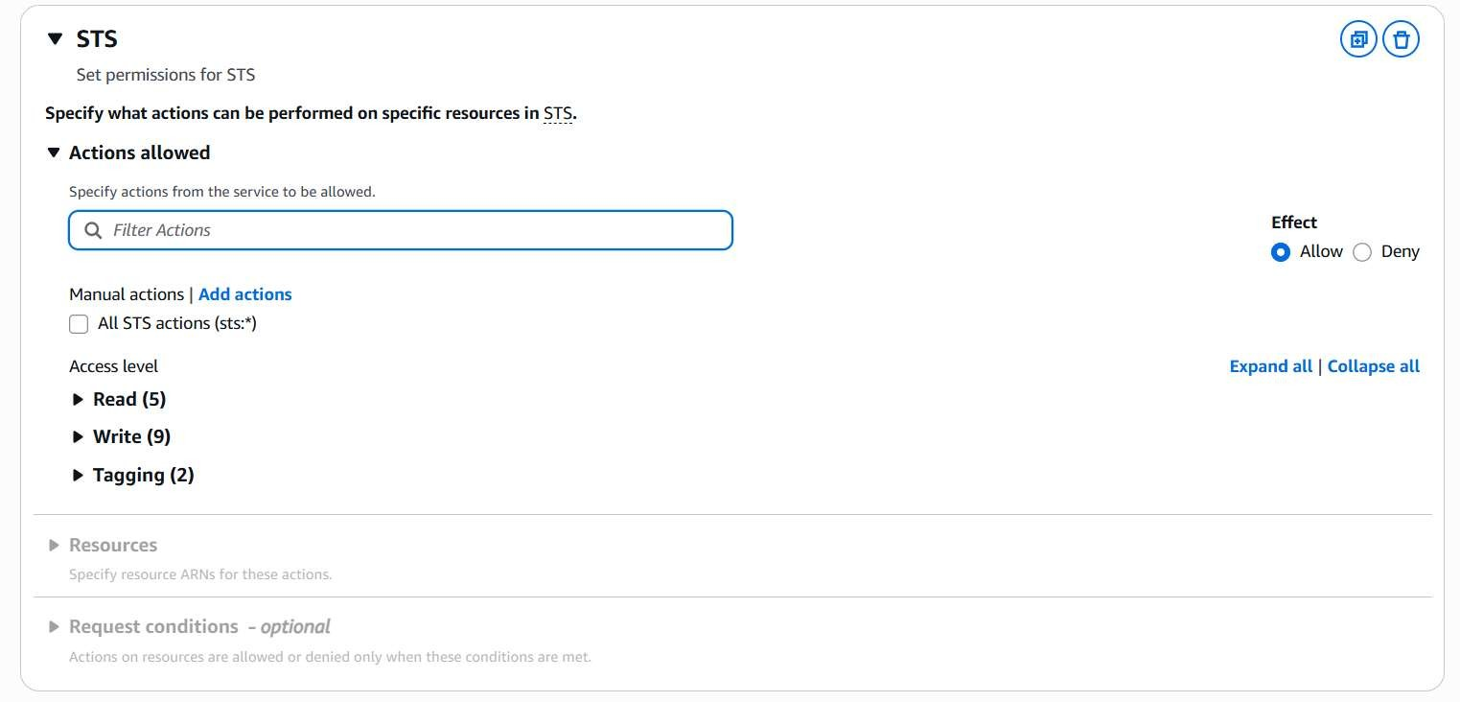
You have to give all permission to the user policy.
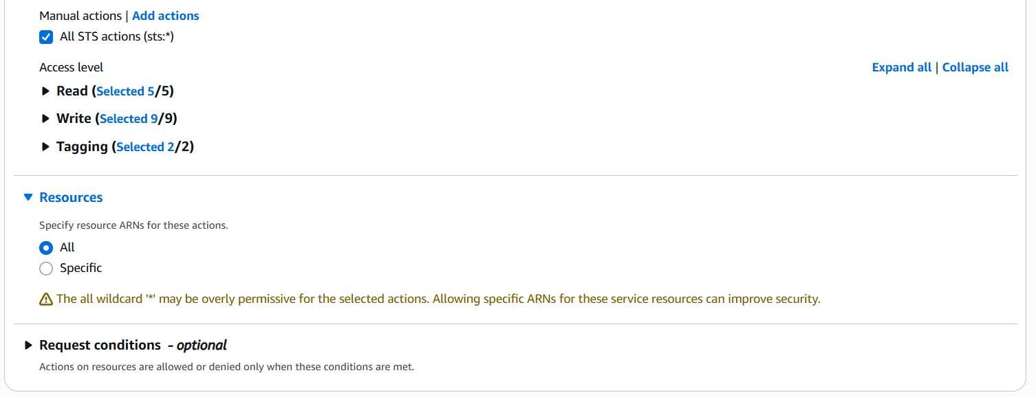
Then I have created the IAM Role to give the access with the Roles.
And then I have connected using IAM User and Switched to the Role.
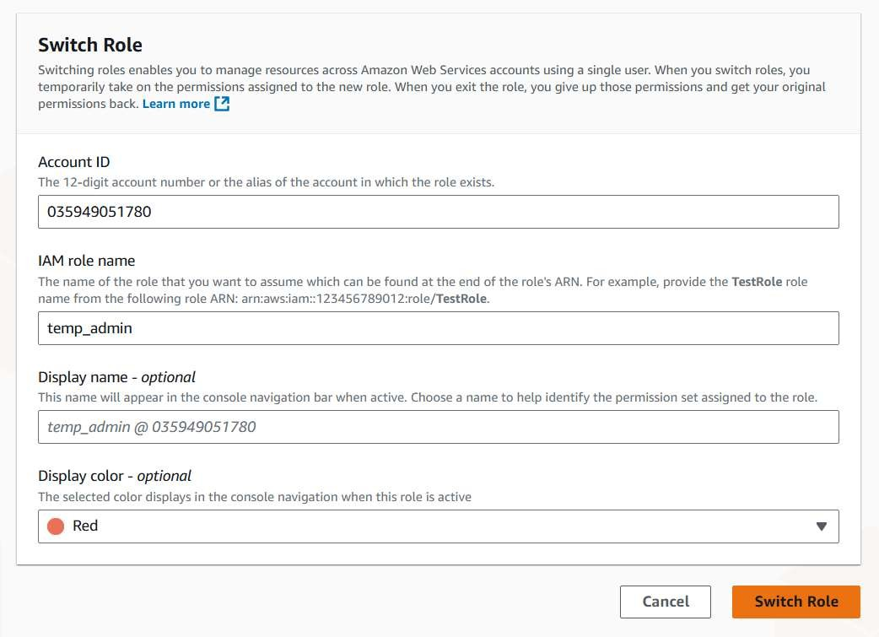
And then we will get this page.
It will give access to all the services.
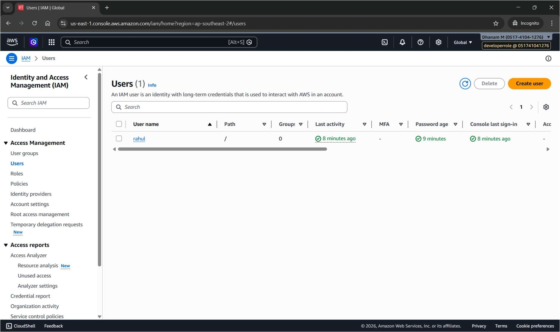
AWS creation of S3 bucket and usage.
What is S3?
Amazon S3 (Simple Storage Service) is object storage.
It stores:
- Files
- Backups
- Static websites
- Docker artifacts
- Logs
- Terraform state files
- CI/CD build outputs
It is:
- Highly scalable • 99.999999999% durable
- Pay for what you use
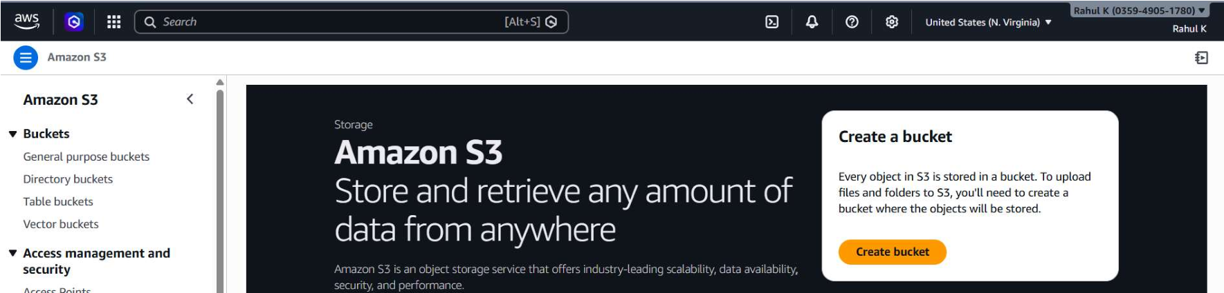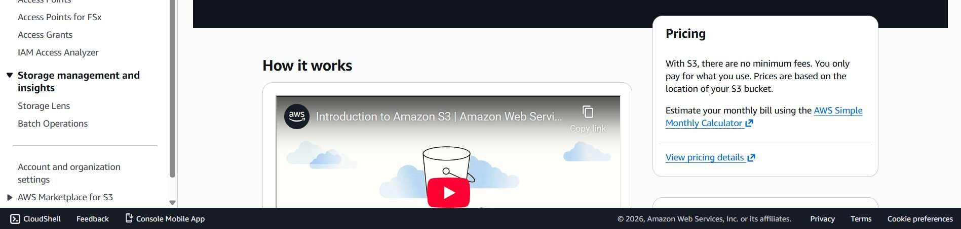
I am creating an new private S3 bucket .
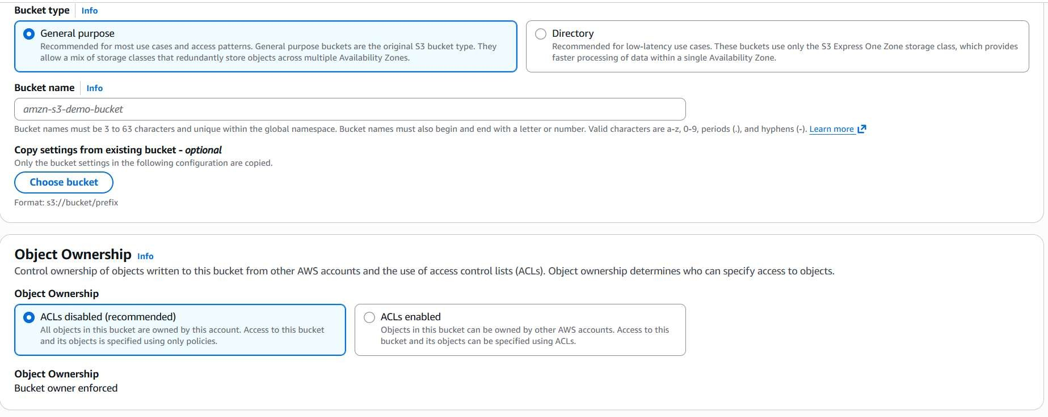
And then I have uploaded the files.
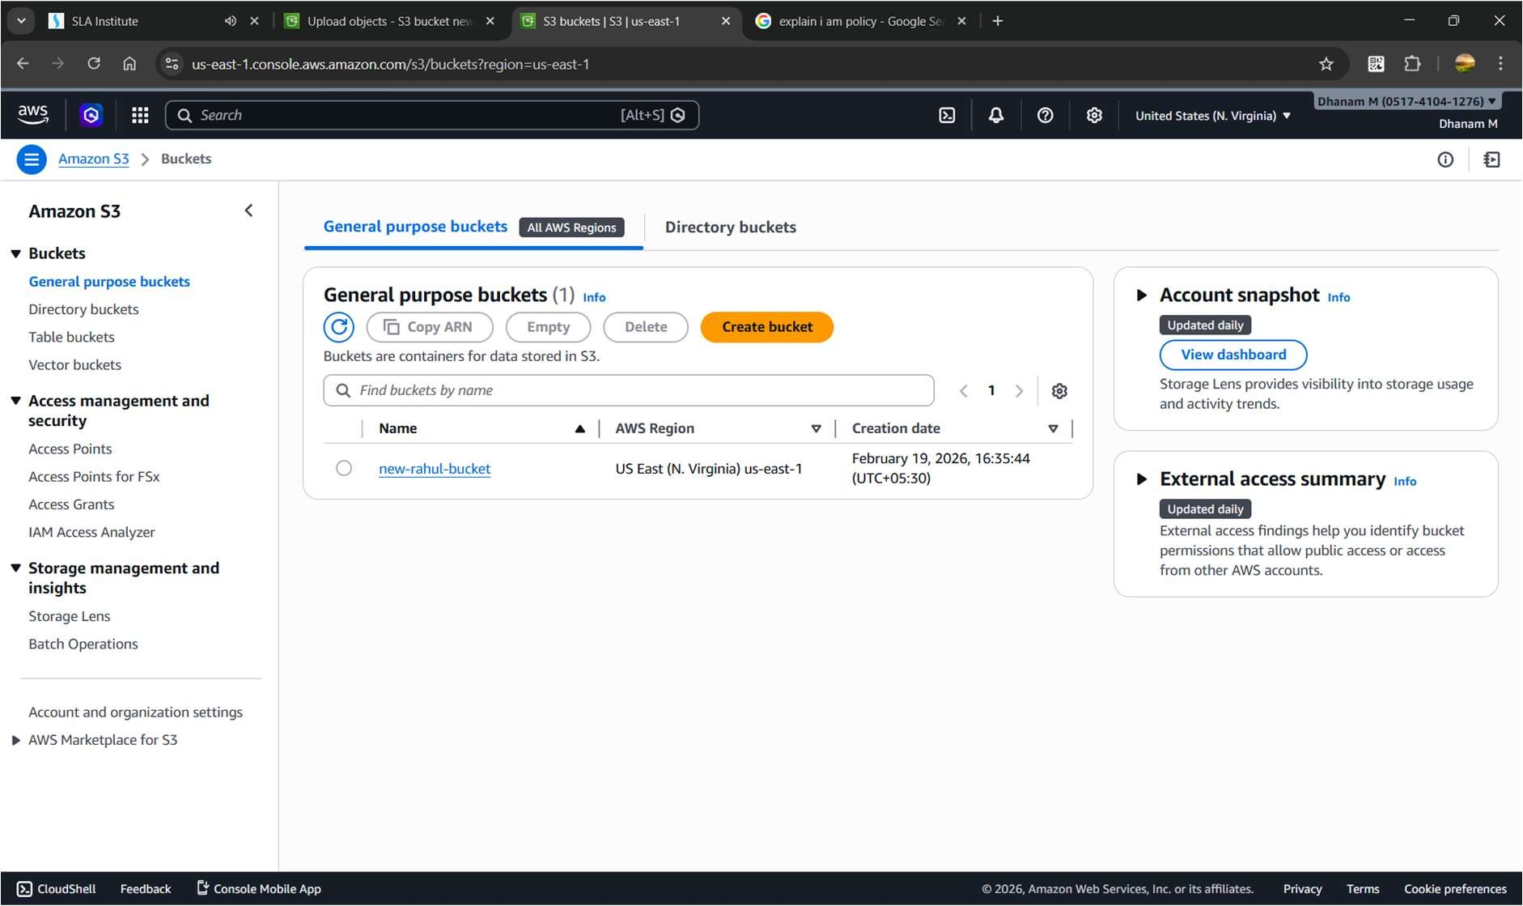
When I want to access the file it says that the access denied.
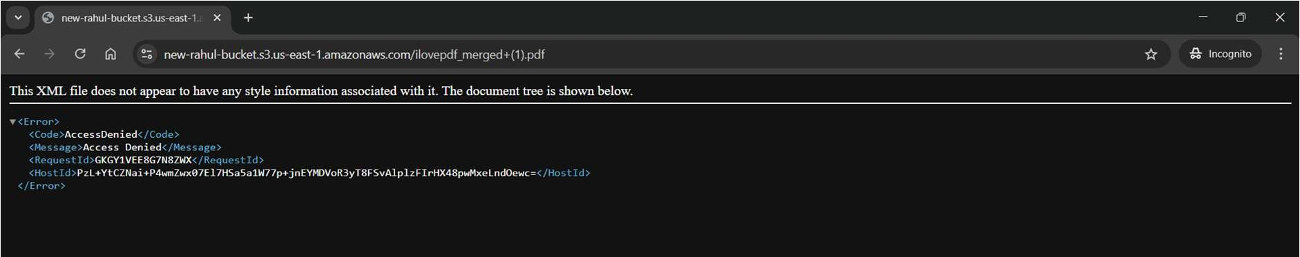
We have to enable versioning for the reusability of older versions.
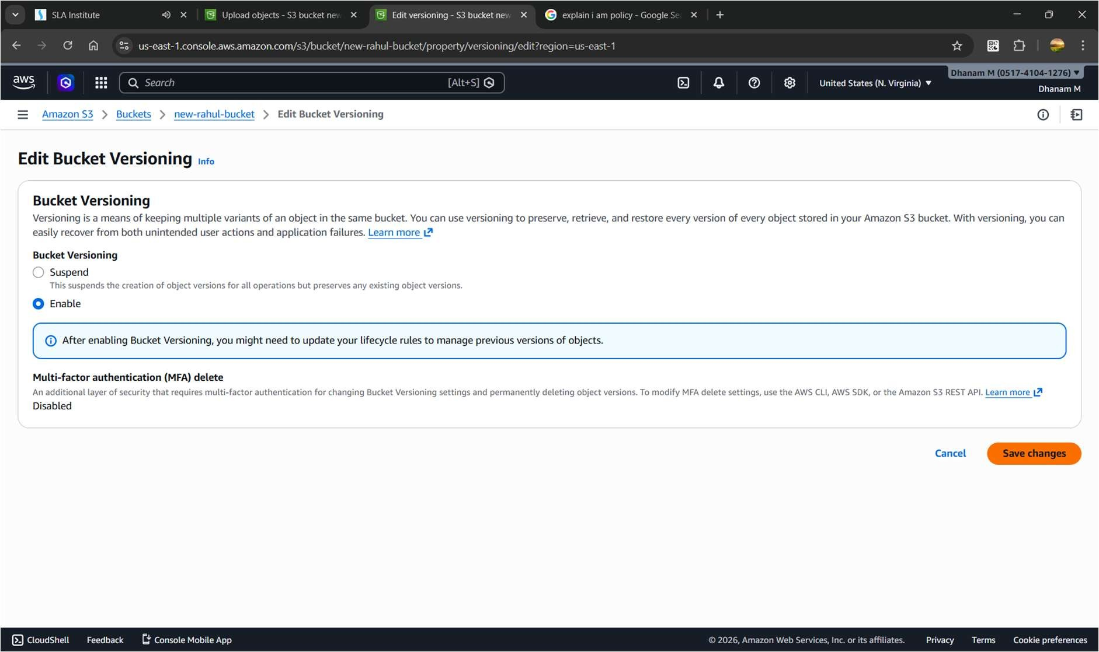
And we have to untick the all checkbox.
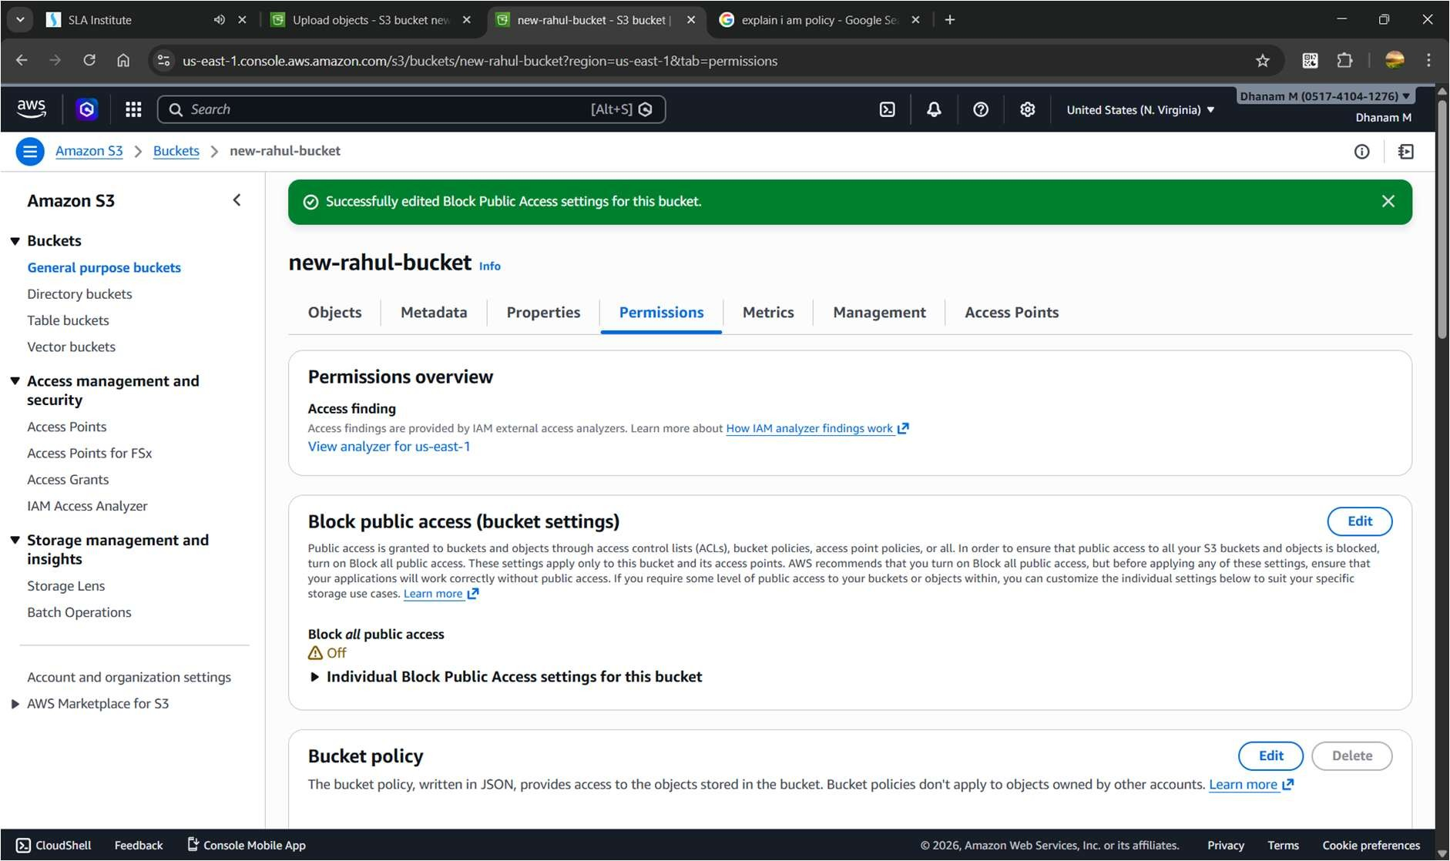
We have to give access to the user with ACL (Access Control Lists)
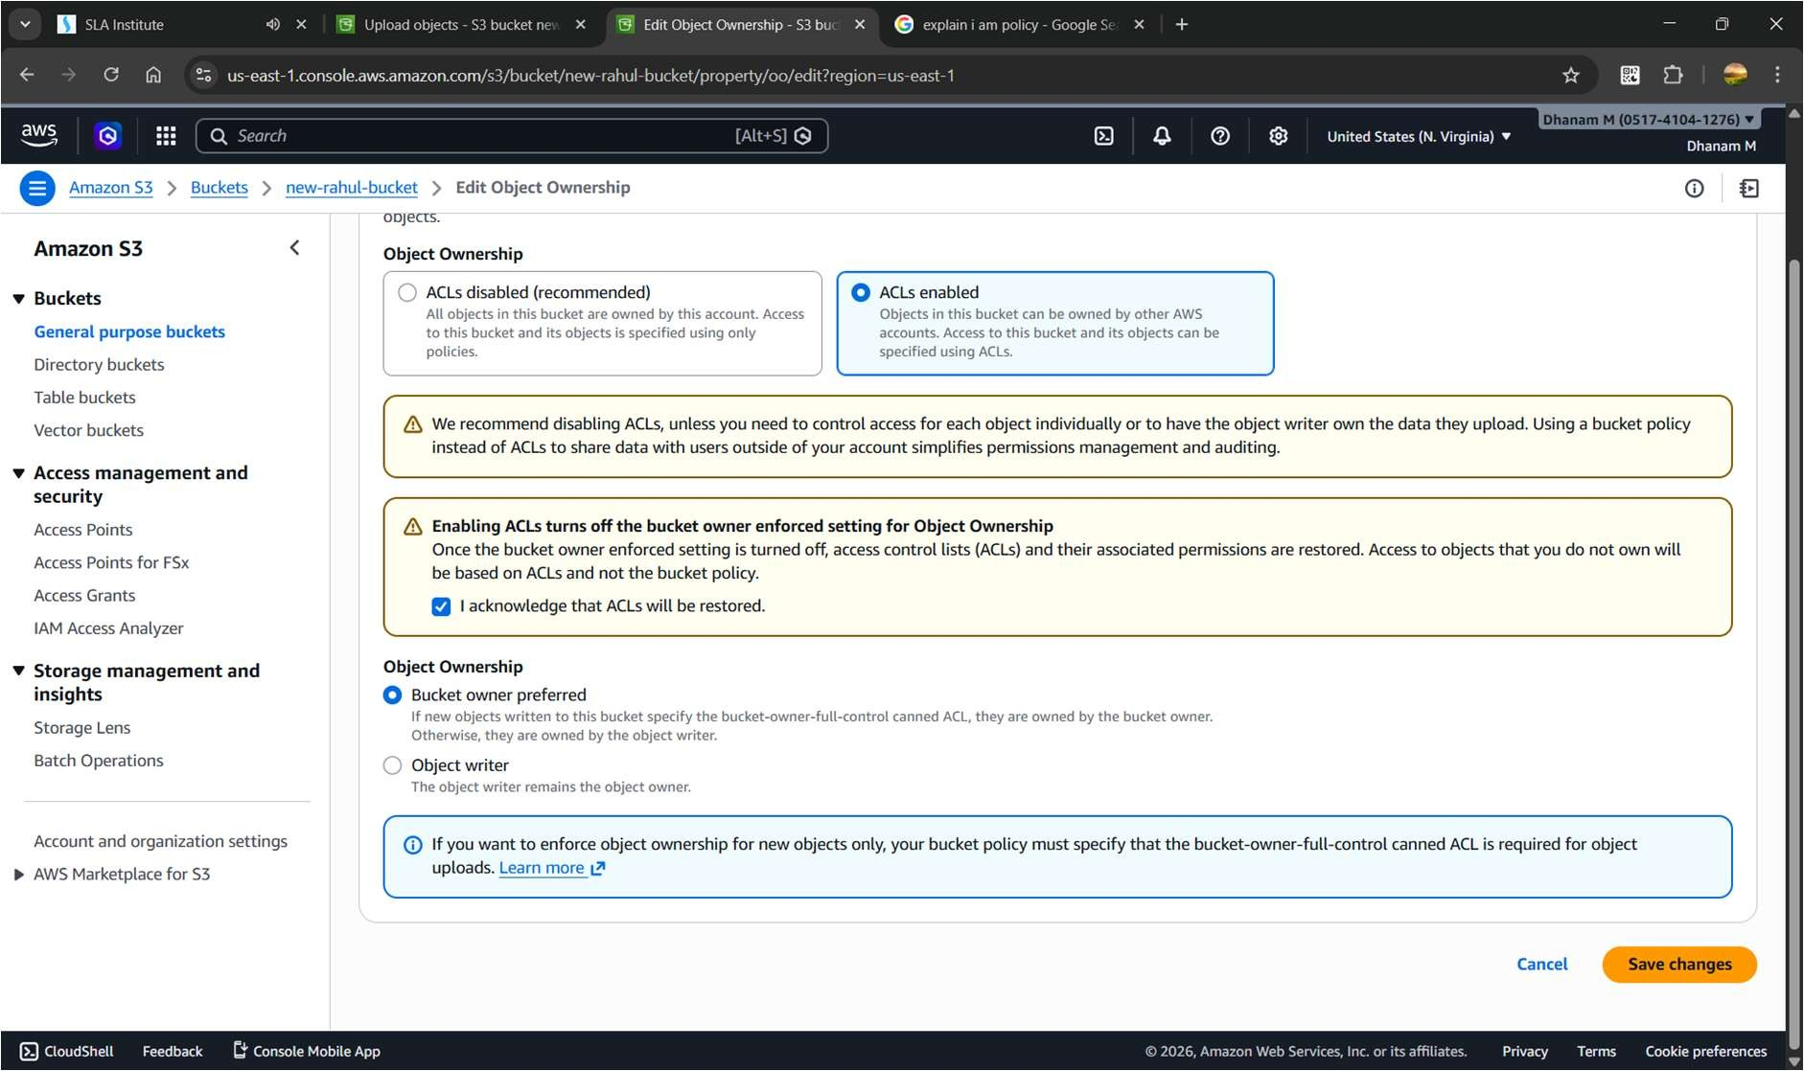
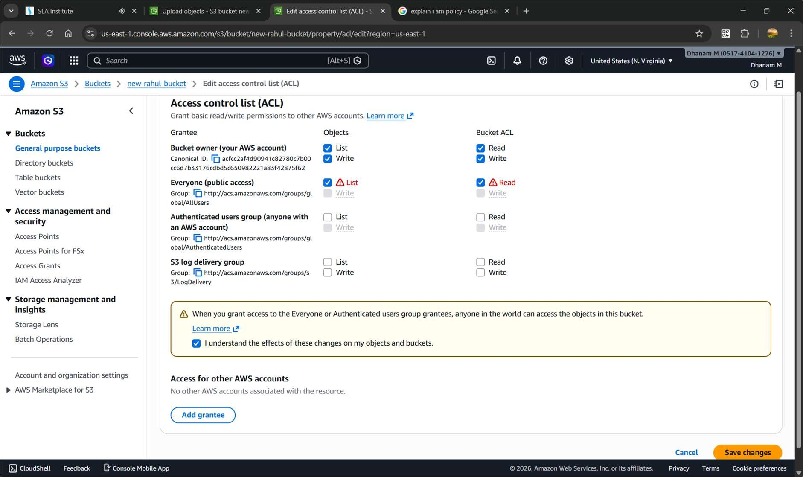
Then we will have the access to the website . S3 has an Adv. Of independent service so it act as an webserver also.
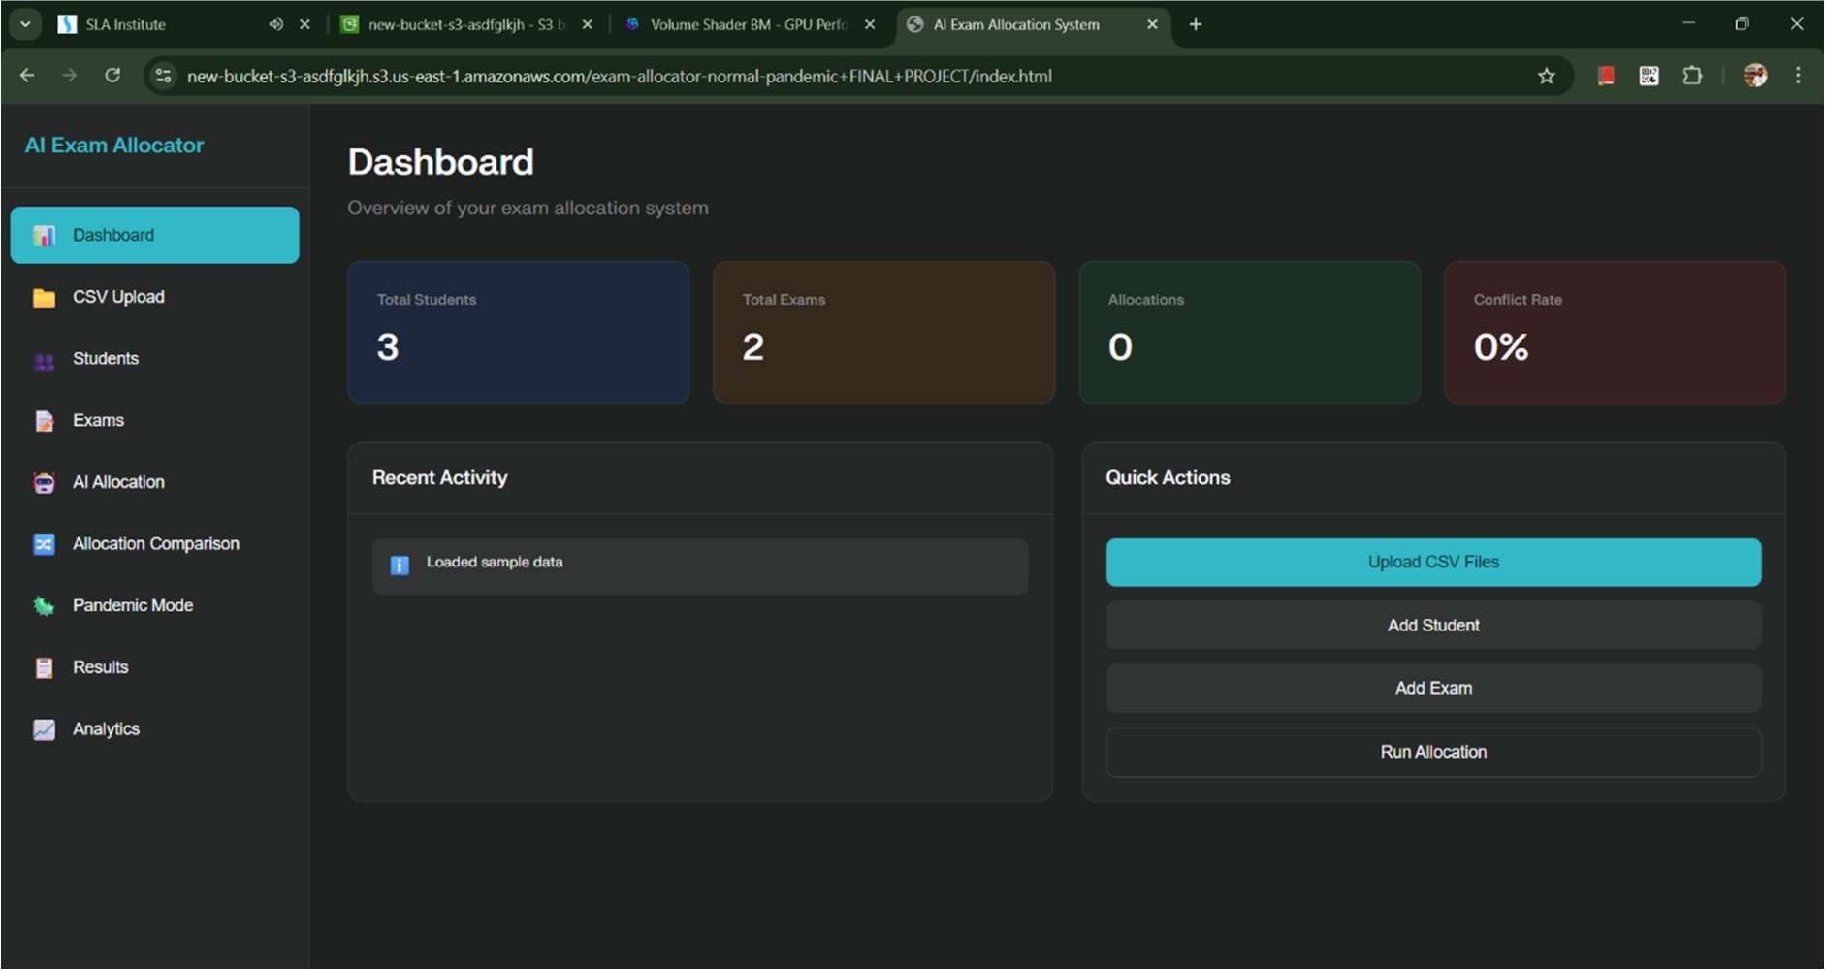
Bucket Versioning.
What it actually is
Bucket Versioning in Amazon S3 means every time you upload, modify, or delete a file (object), S3 keeps the old version instead of overwriting it.
No versioning = new upload replaces old file permanently.
With versioning = old file stays, new file gets a unique Version ID.
Why It Matters (Real Use Cases)
- Accidental delete recovery o If someone deletes project.zip, S3 just adds a Delete Marker. o Old versions still exist. o You can restore them.
- Rollback capability o Broke production config? o Just restore previous version.
- Protection from overwrites o If someone uploads wrong data, you don’t lose original.

Bucket versioning is only suspended not to be disabled , and I have enabled after creating the bucket.
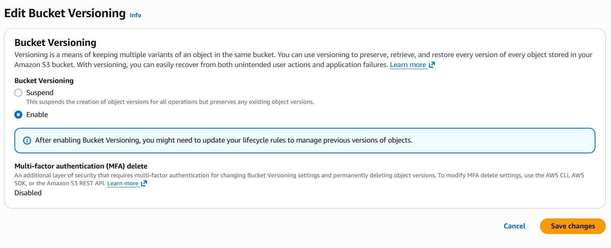
Bucket versioning works like an commit id in github.
I have uploaded 3 files to the bucket.
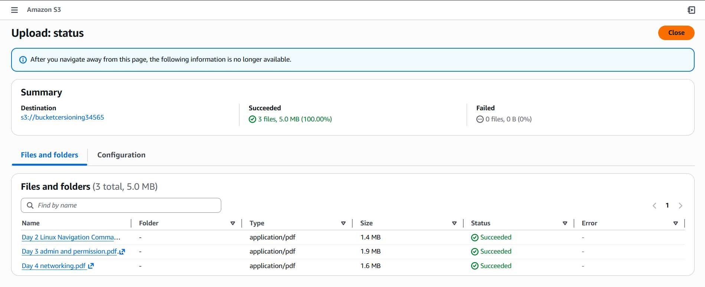
The uploaded files.
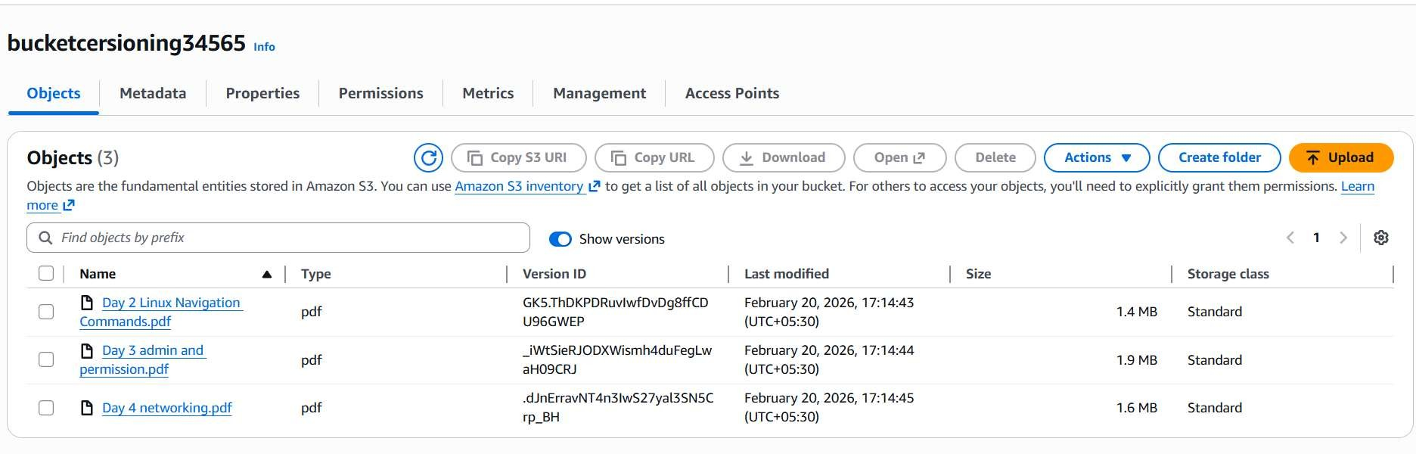
The bucket versioning enabled means the bucket will create and version id we can retriever the older version when we delete the file.
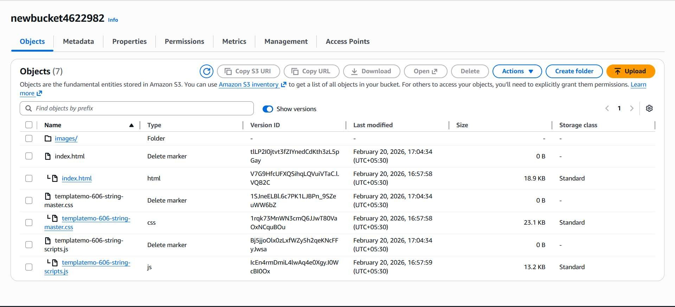

Bucket Replication.
What It Actually Is
S3 Bucket Replication automatically copies objects from one S3 bucket to another.
There are two types:
- CRR (Cross-Region Replication) → Different AWS regions
- SRR (Same-Region Replication) → Same region
Why Replication Exists
Disaster Recovery
- If your primary region fails, your data exists elsewhere.
Low Latency Access
- Users in another country? Store data closer to them.
Compliance
- Some laws require data to exist in specific regions.

Multi-Account Strategy
- Replicate from production account → backup account.

TYPES OF REPLICATION.

  - Cross-Region Replication (CRR)
Replicates objects to a different AWS region.
Example:
- Source → Mumbai region
- Destination → Singapore region
Used for:
- Disaster Recovery
- Global applications
- Region-level failure protection
Reality:
- Costs more (data transfer charges apply)
- Good for serious production setups

  - Same-Region Replication (SRR) Replicates objects to another bucket in the same region.
Used for:
- Log copying
- Compliance separation
- Multi-team access segregation
Cheaper than CRR (no cross-region transfer cost)

  - Cross-Account Replication Replication between different AWS accounts.
Used for:
- Production account → Backup account
- Security isolation
- Enterprise setups Requires:
- IAM role permissions
- Bucket policy on destination
This is how mature DevOps teams operate.

  - Delete Marker Replication
Controls whether object deletions are replicated.
- Enabled → Delete in source = Delete in destination
- Disabled → Destination keeps object even if source deletes I have created two bucket in different regions.
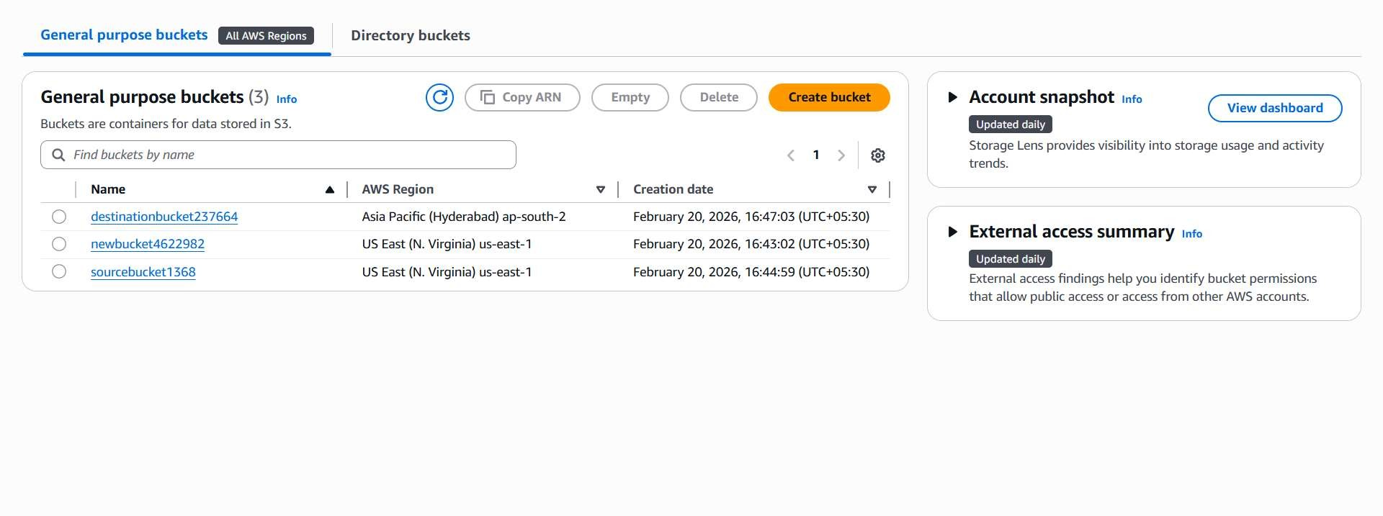
This the source bucket.
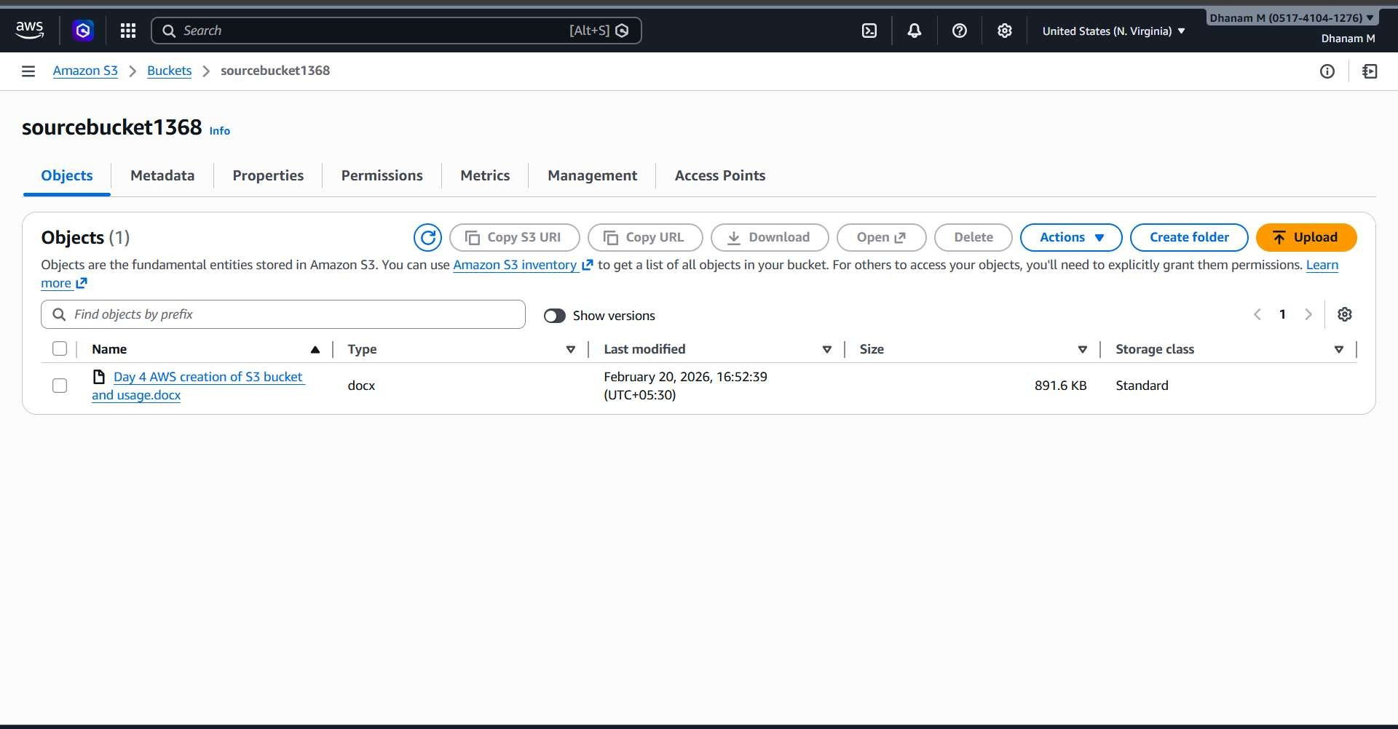
Create replication rule.
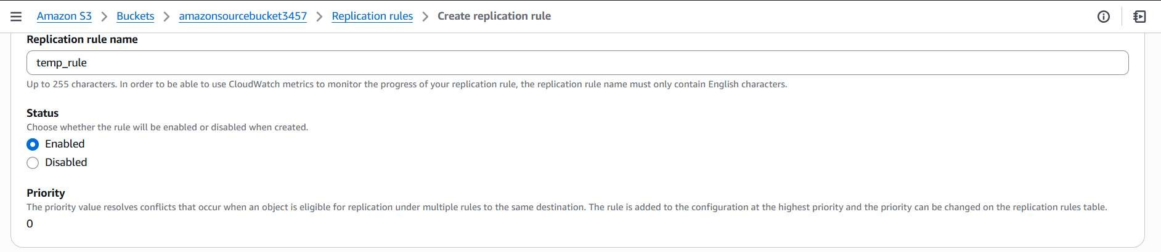
Giving the destination bucket details.
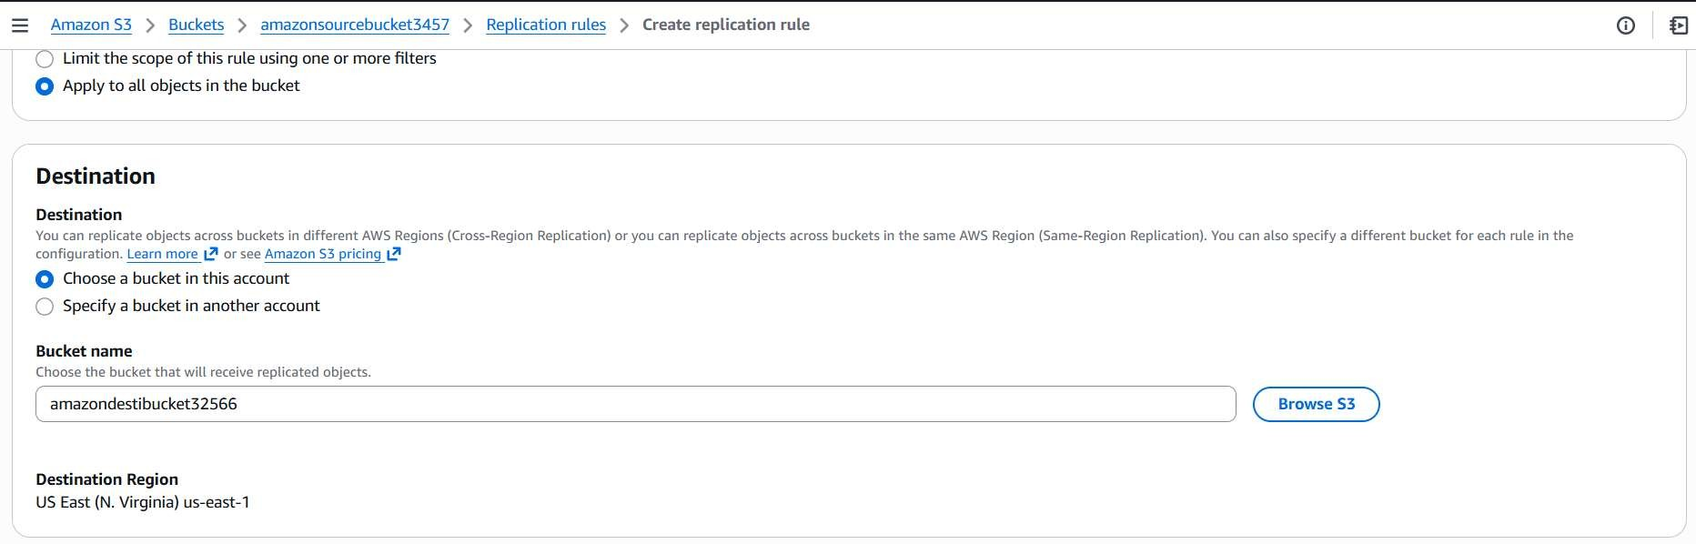
Create own IAM role.
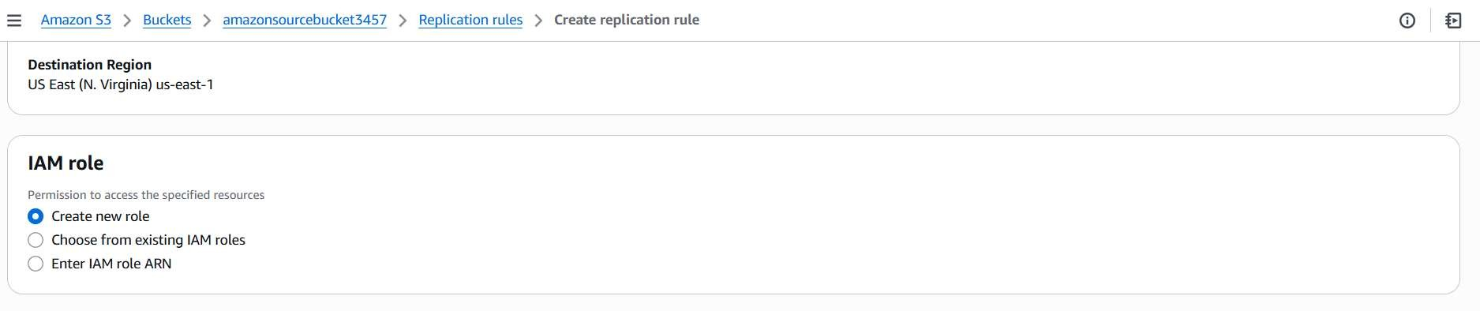
If you want the existing data tick the yes option.
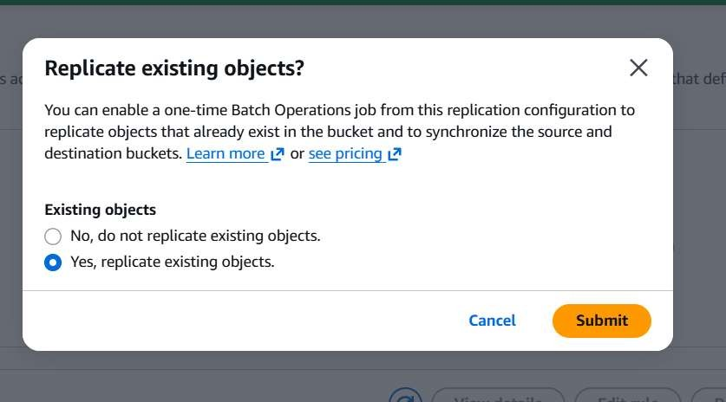
The destination bucket will be updated from 15 minutes to max hours.
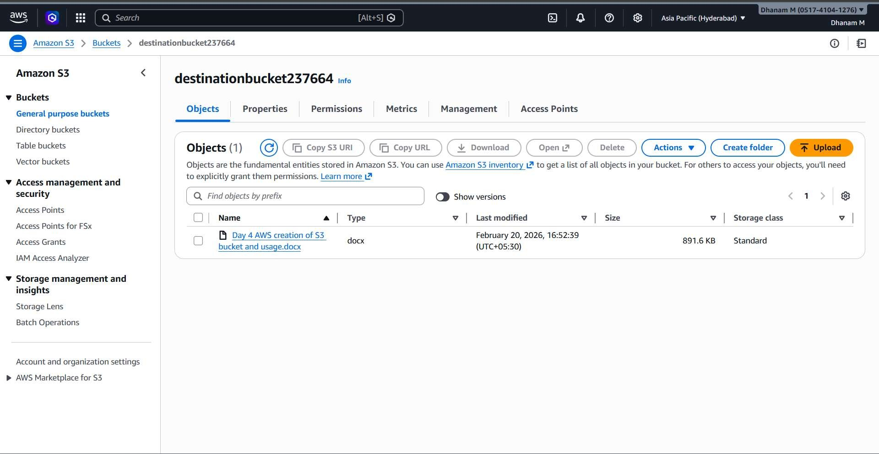

Static Web Hosting.
What You Actually Get
- Cheap hosting
- High durability (11 9’s)
- Auto scaling
- Public HTTP endpoint
- No server management
What you don’t get:
- No server-side code execution
- No HTTPS by default (you need CloudFront for that)
- No database

To enable the static web hosting in the s3 we have to enable ACLs , Bucket versioning , and allow all public access (I have already done it).
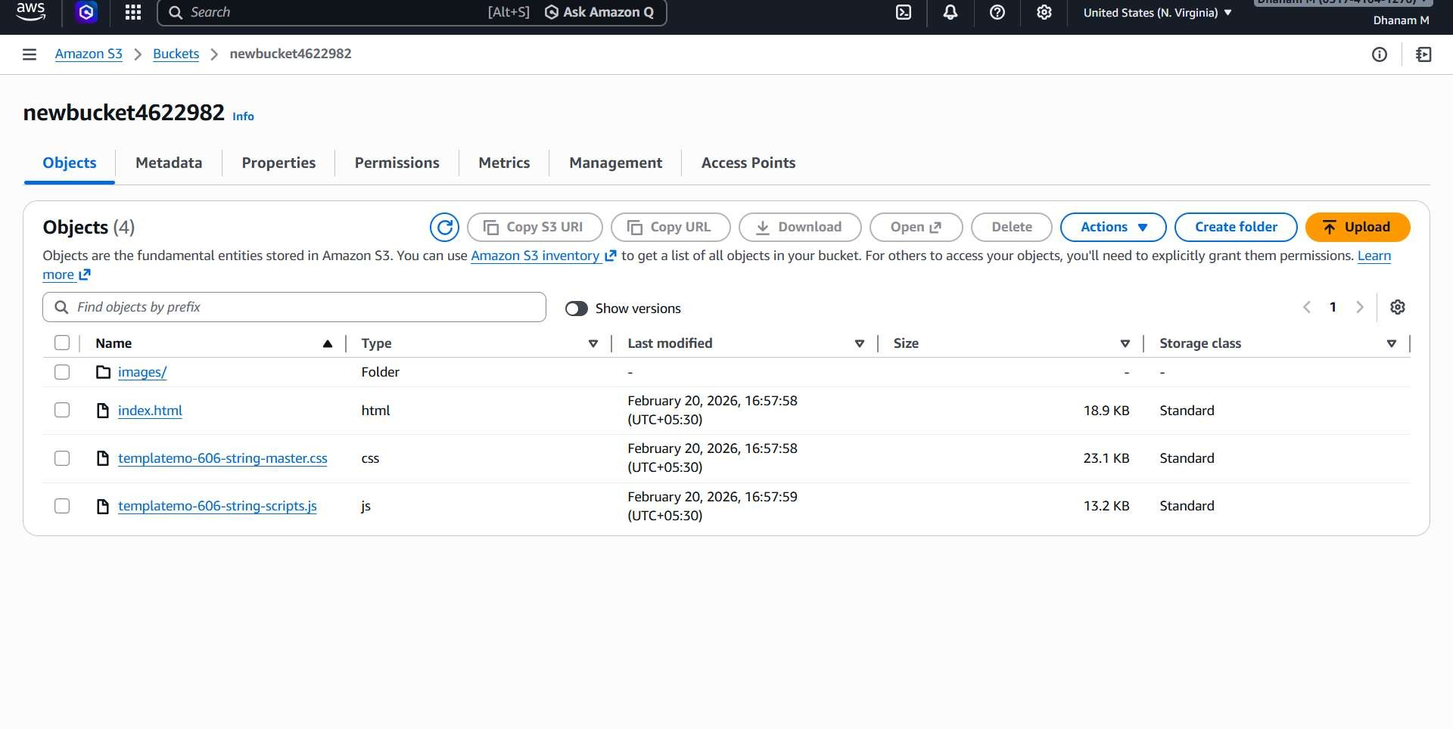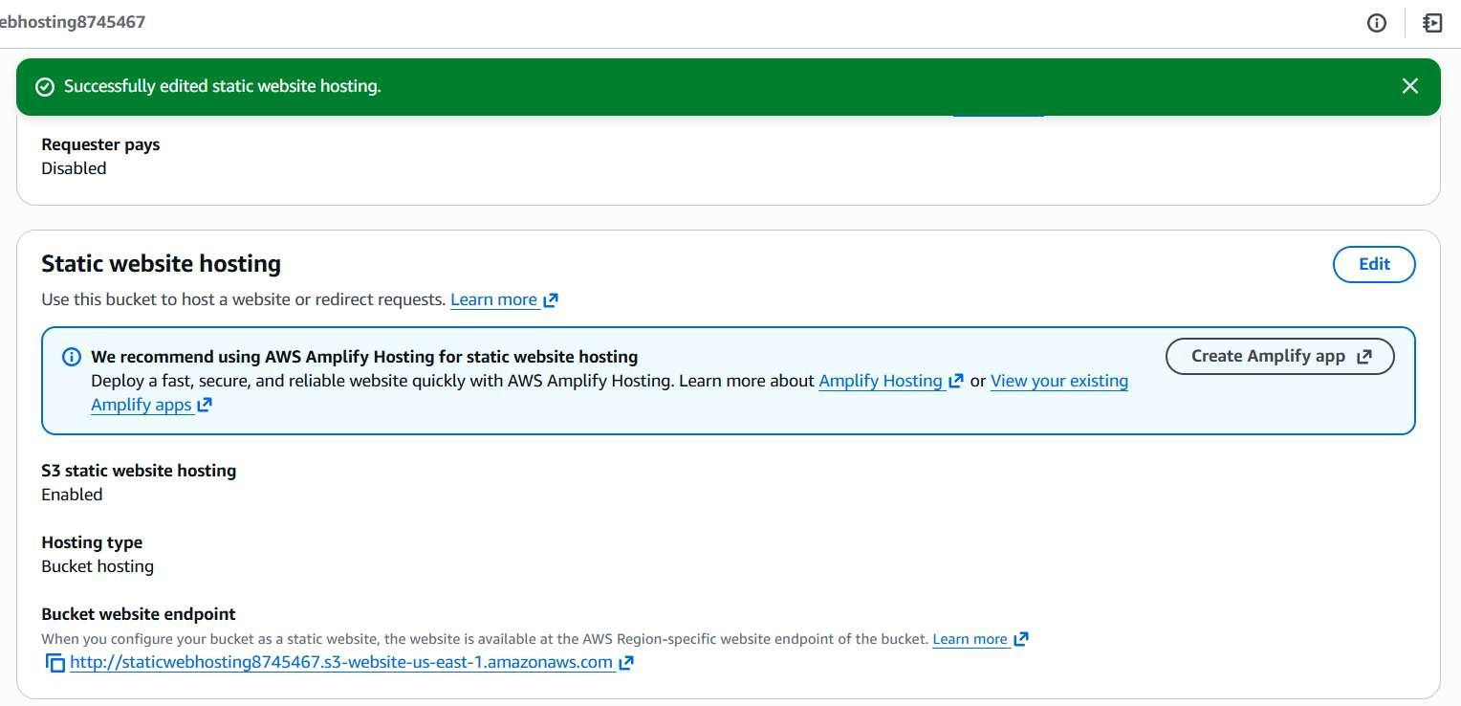
The hosted website is, using the given s3 url.
